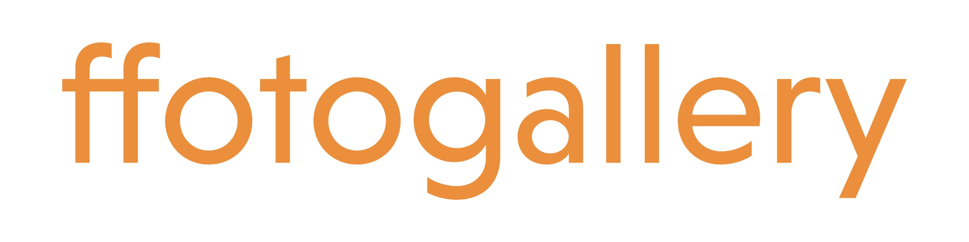
Application Form: Creative Producer

We have prepared a simple application form which we ask you to complete and return by email to alex@ffotogallery.org by 5pm on Friday 27th November 2020. If you would prefer to apply by video, that is also welcomed. In your application, please answer all five questions below. There are no right and wrong answers, we just need to build a picture of who you are and why this opportunity is exciting for you and will help launch your professional career in the arts.

If you need additional guidance and support in making your application, please contact Alex Butler alex@ffotogallery.org and she will be happy to arrange a telephone call to discuss your needs and concerns.

Weston Jerwood Creative Bursaries 2020/22
Creative Producer. One year post (full-time)

Your name:

Address:

Email:

Telephone Number:

Please tell us about your background and education (in approx 250 words). What life experiences have you had which make you a suitable candidate for the role? Please share with us any experiences and personal achievements you feel are relevant.

What first inspired your interest in the visual arts, or the arts more generally? (in approx 150 words) This could be an exhibition, performance or event you attended, a book or film, or your own creative endeavours.

What relevant experience do you have? (in approx 250 words) This experience could be transferable skills gained through paid work, volunteering or internships, or anything relating to your artistic and creative practice.

What would you hope to gain from the experience of working for Ffotogallery as Creative Producer? (in approximately 250 words) You may wish to share with us, for example, your personal development and career goals, any areas of our work that are of special interest to you, and the wider opportunities presented by the Weston Jerwood Creative Bursaries programme.

Is there anything else you would like to tell us or ask about the next stage of the process? (in approximately 250 words) This could be in relation to particular workplace needs or practical considerations such as relocation support, our homeworking policy etc. It might be something about your personal goals, values and beliefs that you haven’t been able to convey in the above questions.

Please note:

All applications will be treated in the strictest of confidence. The Weston Jerwood Creative Bursaries programme requires that all applicants complete and return the attached Monitoring Form with their application. This form is anonymous and will not be used as part of the shortlisting and interview process. The data you give us will also be used for the evaluation of the Weston Jerwood Creative Bursaries programme by Jerwood Charity (trading as Jerwood Arts). Applicant data in anonymous aggregate form will be passed on by Ffotogallery and held according to Jerwood Arts' Privacy Policy.

