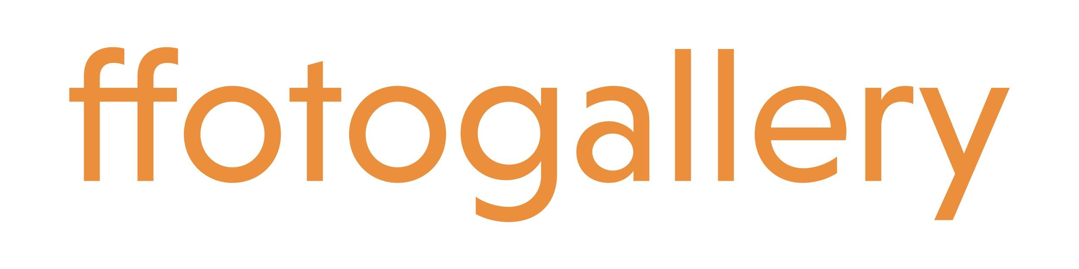
Application Form: Learning and Engagement Manager

We have prepared a simple application form which we ask you to complete and return by email to alex@ffotogallery.org by 5pm on Friday 7th May 2021. If you would prefer to apply by video, that is also welcomed (maximum 5 minutes). In your application, please answer all six questions below.

If you need additional guidance and support in making your application, please contact Alex Butler alex@ffotogallery.org and she will be happy to arrange a telephone call to discuss your needs and concerns.

Learning and Engagement Manager (full-time)

Your name:

Address:

Email:

Telephone Number:

Please summarise your educational achievements and any training or professional development programmes you have successfully completed. (250 words maximum) Ensure that you list dates and any qualifications obtained.

Please list your previous work experience with job title, dates (most recent first) and a brief outline of your responsibilities. (250 words maximum)

What would you bring to Ffotogallery working as Learning and Engagement Manager? (250 words maximum) Please give examples of where your previous experience and achievements, paid or unpaid, are relevant to the role, as defined by the job description and role specification.

From your understanding of Ffotogallery’s work, how would you ensure that our learning and engagement programme tackles social inequalities, and promotes diversity and inclusion? (250 words maximum)

Ffotogallery relies on creating partnerships and collaboration projects. Please describe a successful partnership project that you have undertaken. What, in your view, makes for a fruitful collaboration? (250 words maximum)

Why do you feel that photography and lens-based media are relevant vehicles for learning and engagement work? (250 words maximum)

Is there anything else you would like to tell us or ask about the next stage of the process? (in approximately 250 words) This could be in relation to particular access and workplace needs or practical considerations such as our homeworking policy etc. It might be something about your personal goals, values and beliefs that you haven’t been able to convey in the above questions.

Please note:

All applications will be treated in the strictest of confidence. Ffotogallery’s strategic equalities commitment requires that all applicants complete and return the attached Monitoring Form with their application. This form is anonymous and will not be used as part of the shortlisting and interview process. Only applicant data in anonymous aggregated form will be passed on by Ffotogallery in reports to funders.

